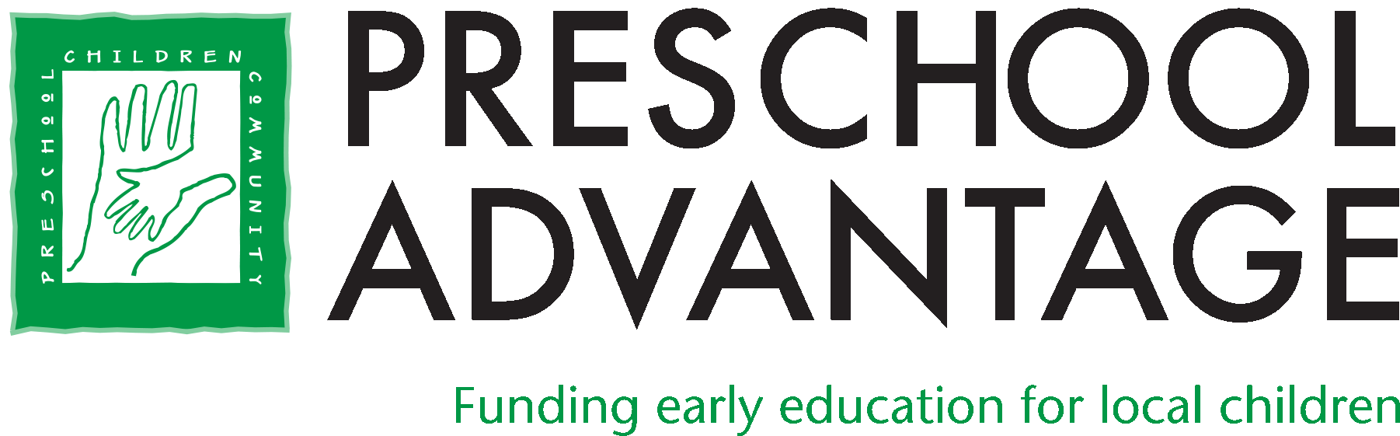
Director of Development Job Description

The Opportunity

Join our team at Preschool Advantage and help us build on the strong legacy of this 28-year-old organization as we set a course for growth, deepening our commitment to providing high quality early education for all children in our community.

Reporting to and working in partnership with the Executive Director, the Director of Development will inherit a well-established fundraising infrastructure. S/he will have the opportunity to lead the development function into its next phase of growth in support of the Organization’s goals.

This position offers opportunities for remote work while maintaining cohesive partnerships with staff and volunteers.

About Preschool Advantage

Preschool Advantage believes in the life-changing benefits of high-quality preschool. Our mission is to raise funds to open the doors of preschool and unlock the possibilities beyond. In preschool, children develop crucial academic and interpersonal skills. Children who attend a high-quality preschool are more likely to stay healthy, graduate from high school, earn a college degree, and become contributing members of society.

At Preschool Advantage, we work with local families who want to provide their children with these wonderful benefits but are unable to afford the cost. Together with our donors, volunteers, and community partners, we provide the foundation for a lifetime of learning that creates a better world for our students, their families, and our community.

Qualities and Qualifications

A successful candidate will have at least five years of experience in a fundraising position and will be skilled in:

- Developing, administering, and achieving the goals of an ongoing annual fundraising program.
- Project management in service of multiple overlapping initiatives.

A successful candidate will be:

- An excellent communicator with strong verbal, written and interpersonal skills.
- An effective representative of the organization in the community.
- A creative thinker who will identify new funding opportunities while valuing the mission-driven culture of the organization.
- Comfortable with Customer Relationship Management software (the office uses Neon CRM) and Excel.

Responsibilities

- Develop and execute Preschool Advantage’s annual fundraising plan, incorporating various channels such as direct mail, donor cultivation, foundation grants, event sponsorship, and more.
- Serve as a member of the leadership team, providing insights and guidance in support of the organization’s Strategic Plan and short & long-term objectives.
- Create and execute a strategy for developing a large, sustained base of annual individual donors.
- Leverage the Development Committee and other volunteers in achieving goals, providing support as necessary.
- Work with the Communications & Events Manager to plan and execute large fundraising events.
- Take a lead role in planning and executing smaller donor cultivation events.
- Develop and track grant proposals and reports for all foundation and corporate fundraising.
- Manage the donor database and share responsibility for data entry and gift acknowledgement.
- Work with entire staff to create content for Annual Update
- Identify and take advantage of opportunities for growth through professional development and networking.
- Undertake other duties as assigned.

Please submit resume and salary requirements to: director@preschooladvantage.org

