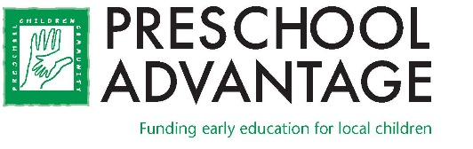

FOR IMMEDIATE RELEASE
Preschool Advantage
25 Lindsley Drive, Suite 307
Morristown, NJ 07960
www.preschooladvantage.org

Contact: Colleen Carey
Email: ccarey@preschooladvantage.org
Phone: 973-532-2501
Preschool Advantage Now Accepting Applications from Local Families Needing Preschool Tuition Assistance for September.

MORRISTOWN, NEW JERSEY – FEBRUARY 8, 2023.
Preschool is critical to a child’s success in school and in life, but the high cost of tuition prevents many families from enrolling their children. Preschool Advantage funds tuition for three- and four-year-olds at 27 high-quality preschools across Morris and Somerset counties, including Children on the Green, The Nursery School of the Presbyterian Church, The Frances & Herbert Brody Preschool of Temple B’Nai Or in Morristown, and Joyful Noise Preschool and Day Care Center and Morris Plains Cooperative Play School in Morris Plains.

Families earning up to $80,000 or more depending on family size, may now apply to Preschool Advantage for funding for the school year beginning in September 2023. Three-year olds will be offered half-day preschool funding. Full-day funding is available for a limited number of four-year-olds on a first come, first served basis. Children must be 3-or 4-years old by October 1, 2023 to be considered for the program. The application deadline is March 1, 2023.

In 2022, 100 local children received assistance from Preschool Advantage. The Organization has provided over 1,200 families with financial assistance for high-quality preschool education since 1995. For the 2023 application and the list of participating preschools, visit www.preschooladvantage.org, call (973) 532-2501 or come to the office at 25 Lindsley Drive, Suite 307, Morristown.

###

