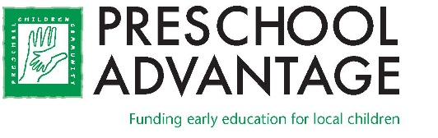

FOR IMMEDIATE RELEASE
Preschool Advantage
25 Lindsley Drive, Suite 307
Morristown, NJ 07960
www.preschooladvantage.org

Contact: Colleen Carey
Email: ccarey@preschooladvantage.org
Phone: (973) 532-2501

Preschool Advantage Announces the Appointment of Ray Hawkins as President of the Board of Directors

MORRISTOWN, NJ January 5, 2022 — Preschool Advantage, a Morristown-based non-profit organization, announces the appointment of Ray Hawkins as President of the Board of Trustees.
Hawkins, a long-serving trustee and former treasurer at Preschool Advantage, is a Senior Vice President at Wealth Enhancement Group. Over the past ten years he has served on numerous board committees at Preschool Advantage, including multiple terms as chair of both Finance and Development. Professionally, Hawkins’ passion for philanthropy inspires him to help clients incorporate charitable giving into their overall financial strategy.
When asked what about Preschool Advantage and its mission keeps him so actively involved, Hawkins explains, “My children attended preschool, and my thinking at the time was that all families had the option to send their children to preschool. When I realized that preschool was not accessible to many New Jersey families, I wanted to help change that.” He went on to say, “My youngest son was very shy, and I saw what preschool did for him. It helped him develop a sense of confidence and independence that served him well as he moved through elementary school and beyond. My goal is for all families in our community to enjoy the same advantages my children did.”
Fellow trustee and local attorney, Matt Mirett describes Hawkins as “a creative, outside-the-box thinker when it comes to fundraising, communications, and strategies.” Mirett adds, “Ray is fully devoted to our mission and that dedication shows through in his many contributions to Preschool Advantage.”
A graduate of Kean University with a BA in Education, Hawkins is a member of the Financial Planners Association (FPA), the Estate Planners Association (GMSEPA), and the Morristown Field Club. He and Carol, his wife of 42 years, have three grown children. In his spare time Hawkins enjoys tennis, golf, platform tennis, pickle ball, and cycling.
Since its inception in 1995, Preschool Advantage has funded tuition for over 1,200 local children. The Organization plans to support an additional 100 children in 2022. To learn more about Preschool Advantage call (973) 532-2501 or visit www.preschooladvantage.org
###
Caption: Ray Hawkins of Basking Ridge, new Preschool Advantage board president

